**Employment Contract Agreement**

This Employment Contract Agreement is entered into on 17th Sep 2023, by and between Loka Design Studio (Via de las dos Castilla 9. Pozuelo de Alarcon Madrid Spain) and Zhao tiezhu (Tuanjiejie Yanjiangwei Liuzu, Jianshi China) collectively “the **Parties**.”

1. Employee shall serve as “sim tint”, reporting to Ferdi Loskamp. Employee shall perform all duties and responsibilities assigned by Employer consistent with Employee's position.
   1. During the employment period, the Employee shall have the responsibility to perform the following duties:
2. “sim tint” developing
3. Employer will pay the Employee 200€ payable.
4. The Employee agrees that he/she will be working from Monday to Friday.
   1. The Employee agrees that he/she will work on average 20 hours per week.
5. The term of this Agreement shall be for a period of 7 days, commencing on the Effective Date and ending on 23th Sep 2023, unless terminated earlier pursuant to the provisions of this Agreement.
6. This Agreement may be terminated by either party upon 23th Sep 2023 days written notice to the other party.
   1. Employer may terminate this Agreement immediately for cause, including but not limited to:
7. Employee’s breach of any material term of this Agreement.
8. Employee’s failure to perform the duties and responsibilities assigned to Employee under this Agreement in a satisfactory manner.
9. Employee’s violation of Employer's policies or rules.
10. Employee’s commission of any act of dishonesty, fraud or misconduct in connection with Employee's employment.
    1. Upon terminating this Agreement, the Employee will be required to return all Employer’s materials, products or any other content at his/her earliest convenience, but not beyond 2 days.
11. All terms and conditions of this Agreement and any materials provided during the term of the Agreement must be kept confidential by the Employee, unless the disclosure is required pursuant to process of law.
    1. Employee shall sign a separate Confidentiality and Non-Competition Agreement with Employer which is attached to and made part of this Agreement.
12. Hereby, the Employee agrees that any intellectual property provided to him/her by the Employer will remain the sole property of the Employer including, but not limited to, copyrights, patents, trade secret rights, and other intellectual property rights associated with any ideas, concepts, techniques, inventions, processes, works of authorship, Confidential Information or trade secrets.
13. This Agreement, together with any exhibits attached hereto, constitutes the entire agreement between the parties and supersedes all prior negotiations, understandings, and agreements, whether written or oral, relating to the subject matter hereof.
14. The Parties agree that any amendments made to this Agreement must be in writing, where they must be signed by both Parties to this Agreement.

The Parties agree to the terms and conditions of this Agreement set forth above as demonstrated by their signatures as follows:

Employer

**Loka Design Studio**

**Ferdi Loskamp**

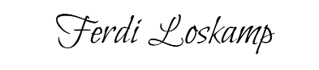

Date: 17th Sep 2023

Employee

**Zhao tiezhu**

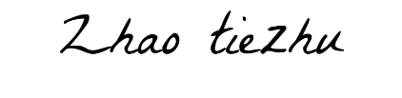

Date: 17th Sep 2023